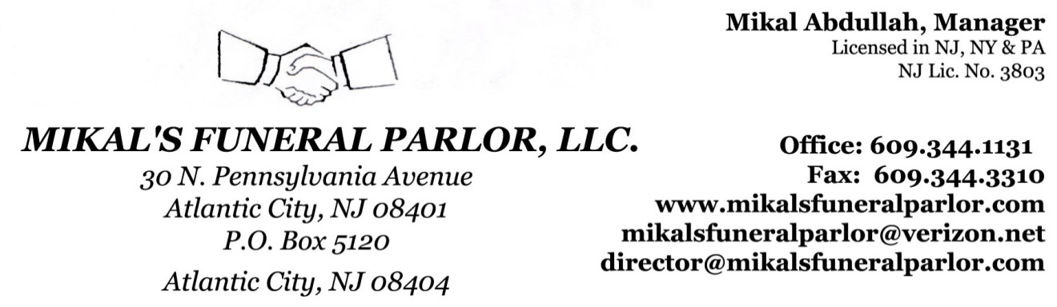
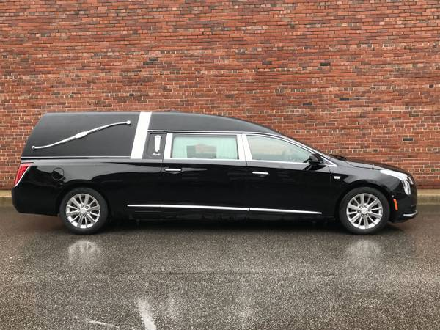
Successful South Jersey funeral home seeking applicants for immediate Full-time, Part-time and/or On-Call status for Funeral/Transport, Administrative, and Funeral Director staff positions. Occasional Night and Weekend availability required. The successful candidate is a professional, well mannered, compassionate individual who is dedicated to providing continued service of the highest quality to our grieving families.
Must have:
- A fondness for Double-Checking - Solid Emotional Control
- A pleasant attitude - The ability to lift up to 50 lbs. - Be very detail oriented - A high level of pride in your work - Great customer service (5 Star Hotel level customer service)
- The ability to interact and collaborate with others in a team atmosphere
- Reliability, a curiosity to learn & professionalism in your DNA.
Repeat, MUST.
If you are OK with just being ordinary, then this opportunity is NOT for you.
Responsibilities: (may include, but not be limited to)
Transfers, Funeral Supervision, Paperwork, Filing, Maintenance, Arrangement assistance, other funeral & office related duties, etc. Valid Driver’s License REQUIRED. Generous Regular/Overtime pay, commensurate with experience, ambition and initiative. Bi-Lingual/Multi-Lingual is a PLU$$$.
Job Type: 1. Funeral/Transport staff 2. Administrative staff 3. Funeral Director
Experience: Funeral Industry = 0-2 years Customer Service = 1-2 years.
Send all Inquiries to: director@mikalsfueralparlor.com .
*Future vacancies for these and other positions, may be filled from the eligible list to be established. The expected life of the eligible list is six months and it may be extended for up to 24 months.

